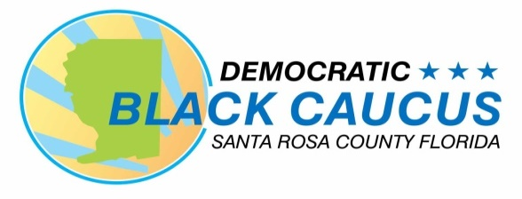

*SANTA ROSA DEMOCRATIC BLACK CAUCUS*

*IS ONE OF OVER 50 COUNTY CHAPTERS OF*

*THE FLORIDA DEMOCRATIC BLACK CAUCUS!*

*YOUR MEMBERSHIP IN THE SANTA ROSA*

*COUNTY DEMOCRATIC BLACK CAUCUS ALSO MAKE YOU A MEMBER OF THE STATEWIDE CAUCUS WITH FULL VOTING RIGHTS IN BOTH!*



**LYDIA HUDSON, PRESIDENT**



**MEMBERSHIP APPLICATION**

JOIN US!

MEETING THE CHALLENGES OF

TOMORROW THROUGH A

STRONGER DEMOCRATIC

**VOICE!**

Your membership will enable us to carry out our mission and meet our objectives for the citizens of Santa Rosa County and the Florida Democratic Party. With your help we will be able to impact the ballot and public policy to build a Florida that respects the rights of all Black citizens!

***Christina Forrest, President***

***Santa Rosa Democratic Black Caucus***

***P. O. Box 4700***

***Milton, Fl 32572***

***850-912-9091***

[***santarosadbc@gmail.com***](mailto:santarosadbc@gmail.com)

***www.srcdbc.org***

**MISSION**

The Santa Rosa County Democratic Black Caucus

(SRCDBC) was established to build up and

reinforce the Florida Democratic Party and to unite

and increase the political power for Black Democrats

by engaging, educating, and empowering the citizens

of Santa Rosa County. SRCDBC works to elect

members to become leaders in the Florida Democratic

Party and work diametrically with local and state

Democratic leaders and elected officials, the Democratic

Black Caucus of Florida, Democratic Executive

Committees, and the Florida Democratic Party.

**VISION**

As a result of its work and its standing in solidarity in

addressing issues that are impacting our daily lives,

SRCDBC can develop solutions and strategies to

address these issues. As we lift and educate

the voters of Santa Rosa County, we will in turn impact

the Ballot and public policy to build a Florida that

respects the rights of all Black citizens, and provides

access to quality healthcare and jobs, addresses

pervasive poverty, supports public employees, and

insures that all citizens can fully exercise their voting

rights and civil liberties.

**JOIN SRCDBC!**

**Fill out the form below and submit with the annual membership fee as appropriate:**

**_______ x $50 for ages 64 and younger: Total $___________**

**_______ x $30 for seniors (65+) /students: Total $___________**

**Note: $35 of adult and $15 of senior/student membership fee goes to the Democratic Black Caucus of Florida, which makes you a member of both the state and local DBC.**

Date:_________________________

Name:_____________________________________________________

Name:_____________________________________________________

Address:___________________________________________________

City:_________________________ Zip:__________________

County:_________________________ Congressional District:_________

FL House District: ______________ Senate District:_________________

E-mail:_____________________________________________________

Phone Number:______________________________________________

Occupation: _________________________________________________

Political/Committee/Service Interests:_____________________________

_________________________________________________

New Member:________ Renewal Membership ___________

Signature:_________________________________________

Make checks or money orders payable to:

Santa Rosa County Democratic Black Caucus or SRCDBC

Mail to: P. O. Box 4700, Milton, Fl 32572